Amazon Web Services
Identity and Access Management (IAM)
AWS IAM (Identity and Access Management) is a service used to manage users, groups, and permissions in our AWS account. It allows us to control who can access what, ensuring secure and organized usage of AWS resources. IAM users are real people or applications who log in and perform tasks. IAM groups help manage permissions for multiple users at once. IAM roles provide temporary access for services or external users without sharing passwords or keys.

Screenshot1 - Specify User Details
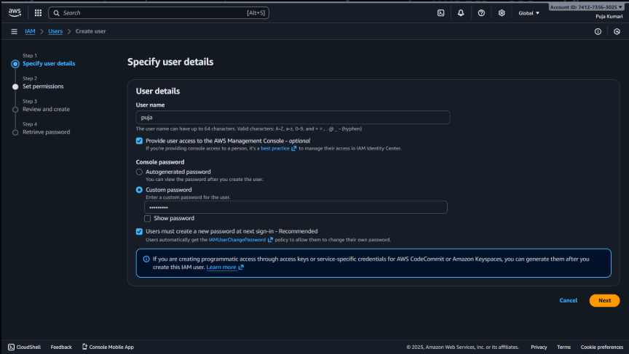
Explaination:-
- This screen is used to create a new IAM user named “puja”.
- Console access is enabled so the user can log in to the AWS Management Console.
- A custom password is set, and the user must change it during the first login.
- This step defines the basic login information for the new IAM user.

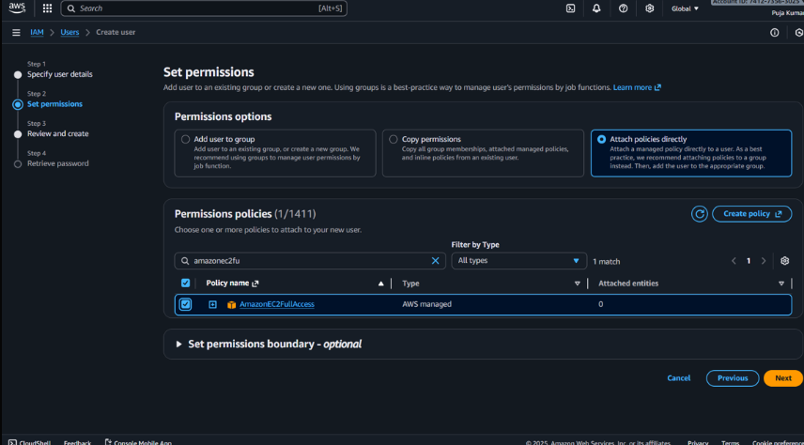
Screenshot2 - Set Permissions
Explaination:-
- This step assigns permissions to the newly created IAM user.
- The user is given the AmazonEC2FullAccess policy, allowing full access to EC2 services.
- Permissions are attached directly to the user instead of using a group.
- We can add more policies or create our own from this page.
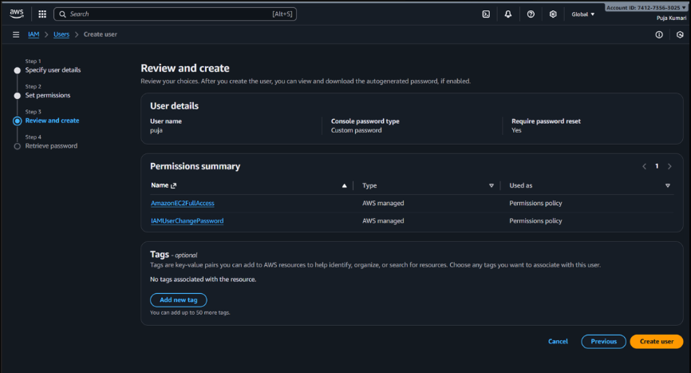
Screenshot3 - Review and Create
Explaination:-
- This screen shows a summary of the new IAM user settings before creation.
- It lists the applied policies: AmazonEC2FullAccess and IAMUserChangePassword.
- Optional tags can be added but none are selected here.
- Clicking Create user finalizes the setup.
Screenshot4 - Retrieve Password
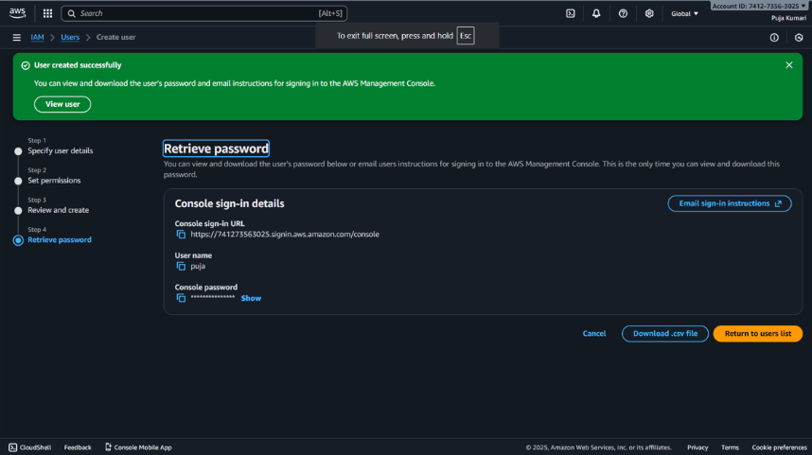
Explaination:-
- This confirms that the IAM user “puja” was created successfully.
- It shows the console login URL, username, and the generated or custom password.
- This is the only time the password can be viewed or downloaded.
- We can download a .csv file containing the login credentials for safekeeping.

